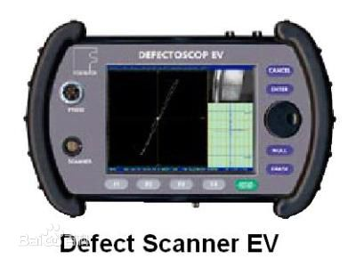

To detect the crack on the surface

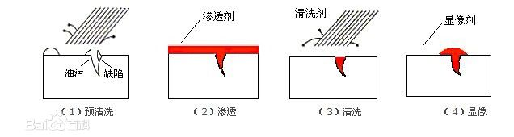

Spray fluorescer one the surface and wipe it out. Then it will remain in the crack.

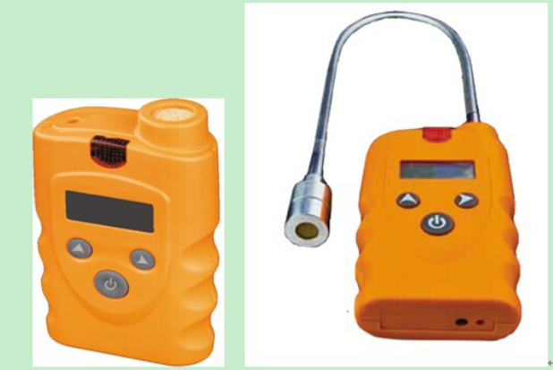

The sensor to detect the smell of all the gas which can burn.